

**Lab Manual- Create EC2 Instance for Linux and Connect to it.**

**Date:-10/08/2021**

**Prepared By: Shweta Chavan**

**Prepared For:**

**Course:**

**Document Name: Lab Manual**

**TABLE OF CONTENTS:**

| **1** | **Objective** | **3** |
| --- | --- | --- |
| **2** | **EC2 Instance Types** | **3** |
| **3** | **Pre Requisites** | **3** |
| **4** | **Creating Linux EC2 Instance** | **4** |
| **5** | **Connect to the Linux Instance** | **10** |
| **6** | **Clean Up Your Instance** | **21** |

**SECTION 1 OBJECTIVE**

An instance is a virtual server in the AWS Cloud. With Amazon EC2, you can set up and configure the operating system and applications that run on your instance.

Amazon EC2 provides a wide selection of instance types optimized to fit different use cases. Instance types comprise varying combinations of CPU, memory, storage, and networking capacity and give you the flexibility to choose the appropriate mix of resources for your applications.

EC2 Instance can even be launched with help of AWS CLI

**Note:** *When you sign up for AWS, you can get started with Amazon EC2 using the* [*AWS Free Tier*](https://aws.amazon.com/free/)*. If you created your AWS account less than 12 months ago,and have not already exceeded the free tier benefits for Amazon EC2, it will not cost you anything to complete this tutorial, because we help you select options that are within the free tier benefits. Otherwise, you'll incur the standard Amazon EC2 usage fees from the time that you launch the instance until you terminate the instance (which is the final task of this tutorial), even if it remains idle.*

**SECTION 2 EC2 Instance types**

It is important to select the right instance size and type for the working of our virtual machine perfectly. So, these are the types that are available within AWS.

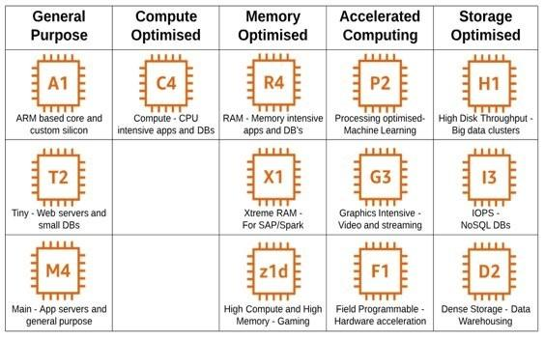

**SECTION 3 PRE-REQUISISTE**

* **Accounts in AWS**
* **A local Computer with 4 CPU, 16 GB RAM, 200 GB disk space**

**SECTION 4 CREATING A LINUX INSTANCE**

To launch an instance

1. Open the Amazon EC2 console at ***https://console.aws.amazon.com/ec2/.***

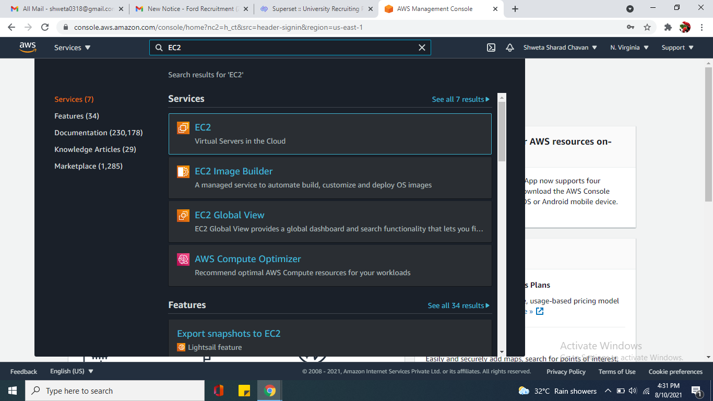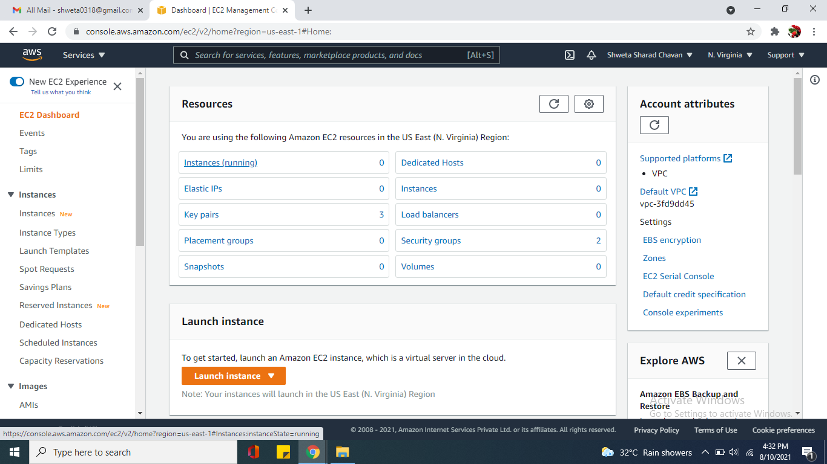

1. From the console dashboard, choose Launch Instance.

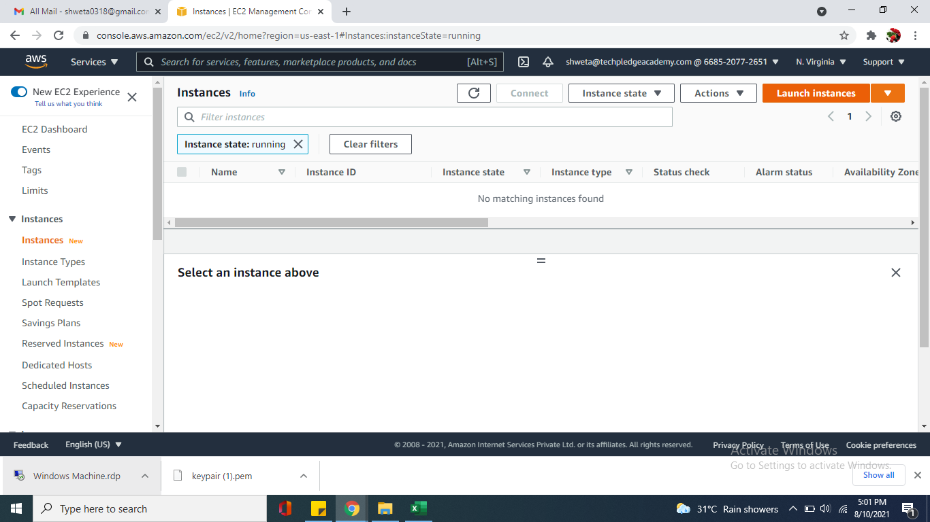

1. The Choose an Amazon Machine Image (AMI) page displays a list of basic configurations, called Amazon Machine Images (AMIs), that serve as templates for your instance. Select an HVM version of Amazon Linux 2. Notice that these AMIs are marked "Free tier eligible."

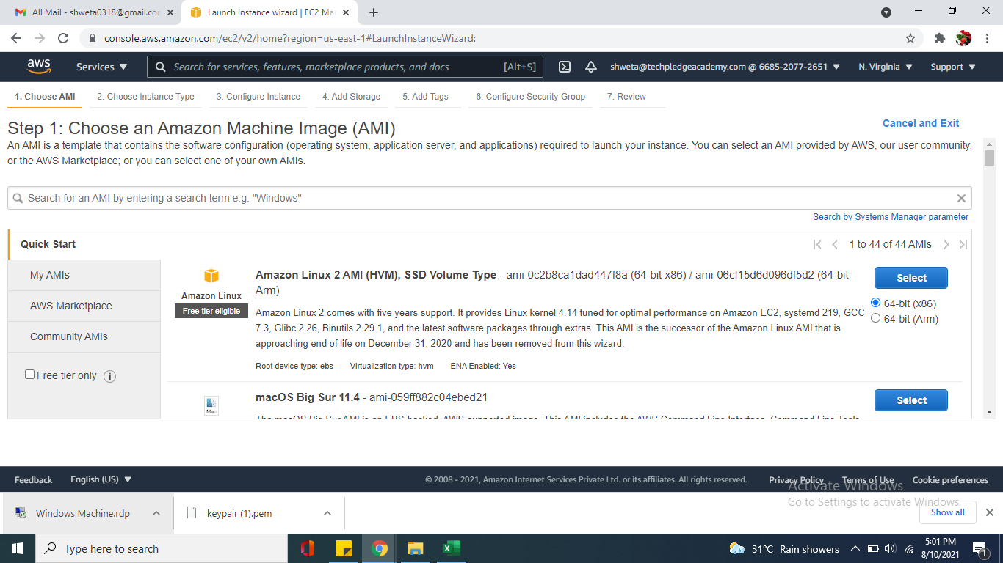

1. On the Choose an Instance Type page, you can select the hardware configuration of your instance. Select the t2.micro instance type, which is selected by default. The t2.micro instance type is eligible for the free tier..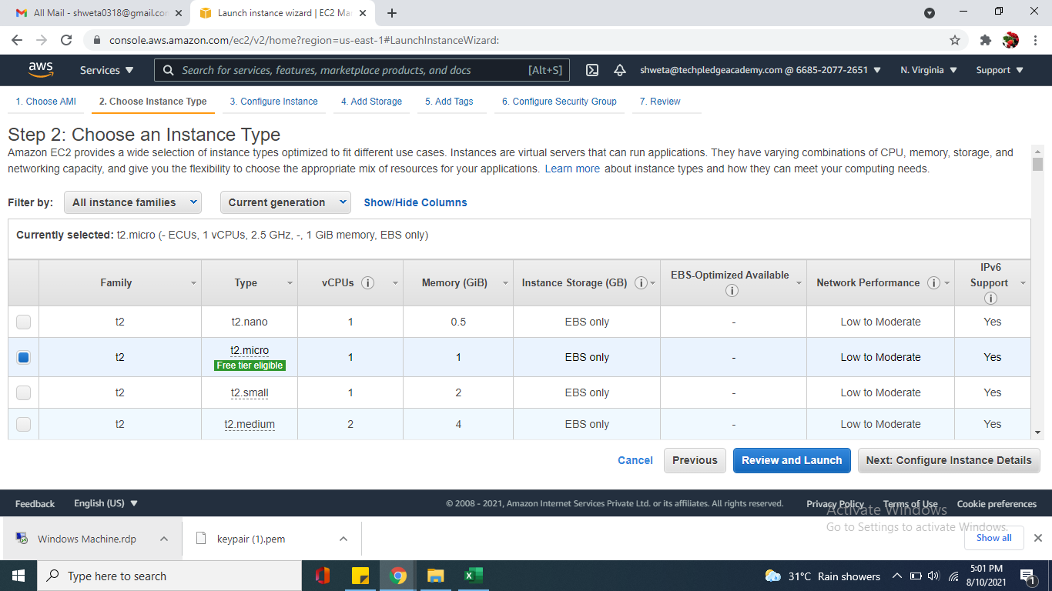
2. Configure the instance detail for training purpose keep all default , move next add storage keep default in add tags give a name linux machine and click on Configure Security Group.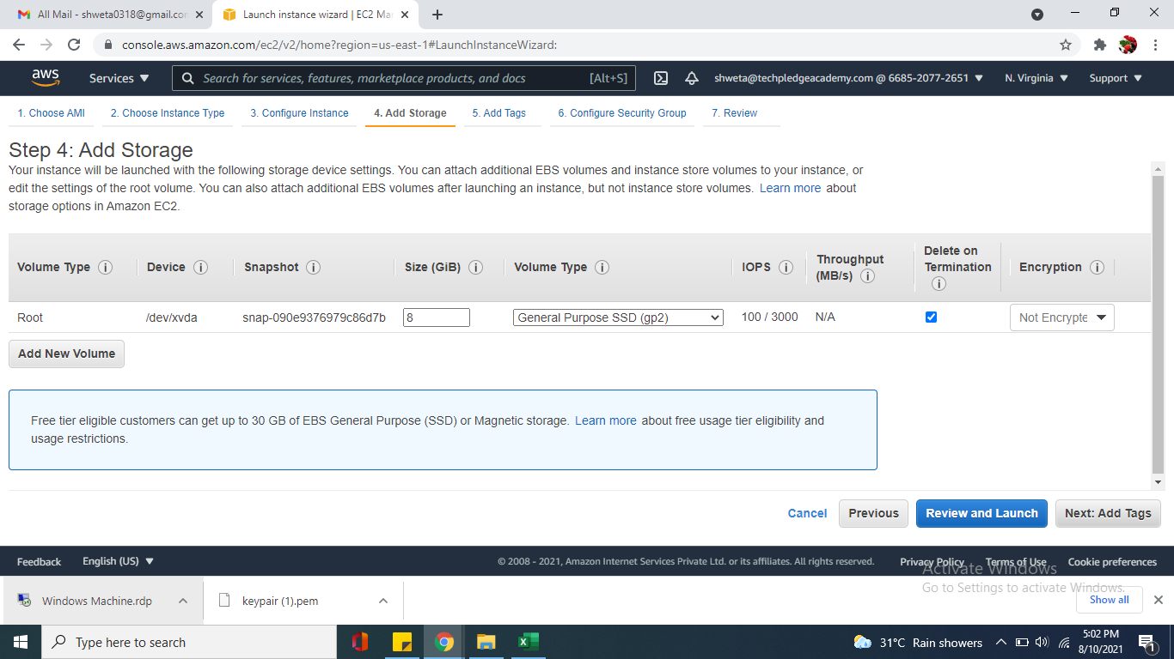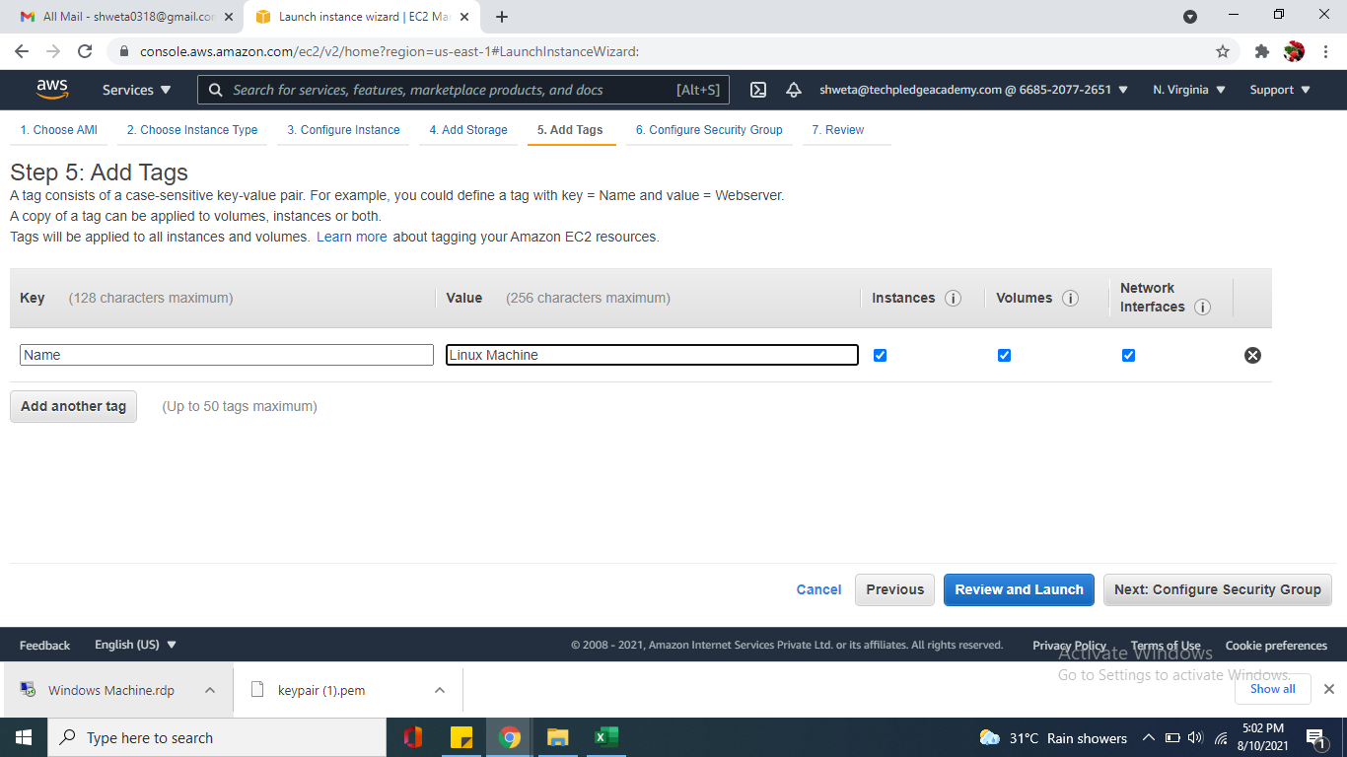
3. On Step 6 Configure Security Group , Create a new security group name it and describe it then click review and launch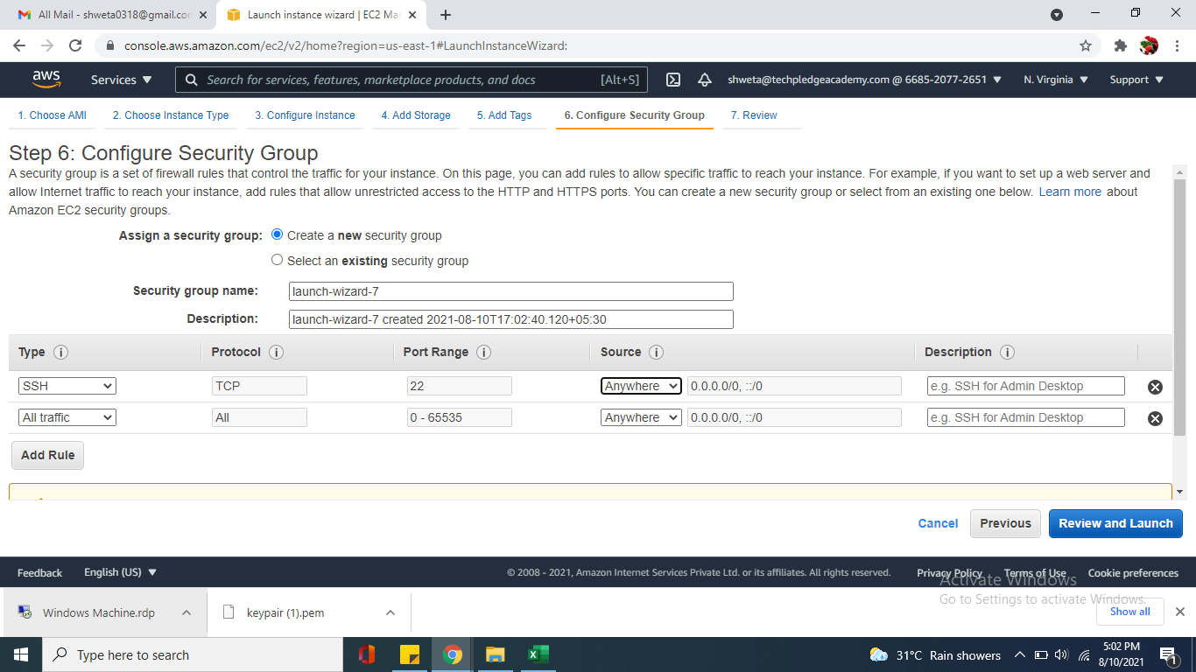
4. On the Review Instance Launch page, choose Launch.When prompted for a key pair, select Create a new key pair and give key pair name and download the key pair.

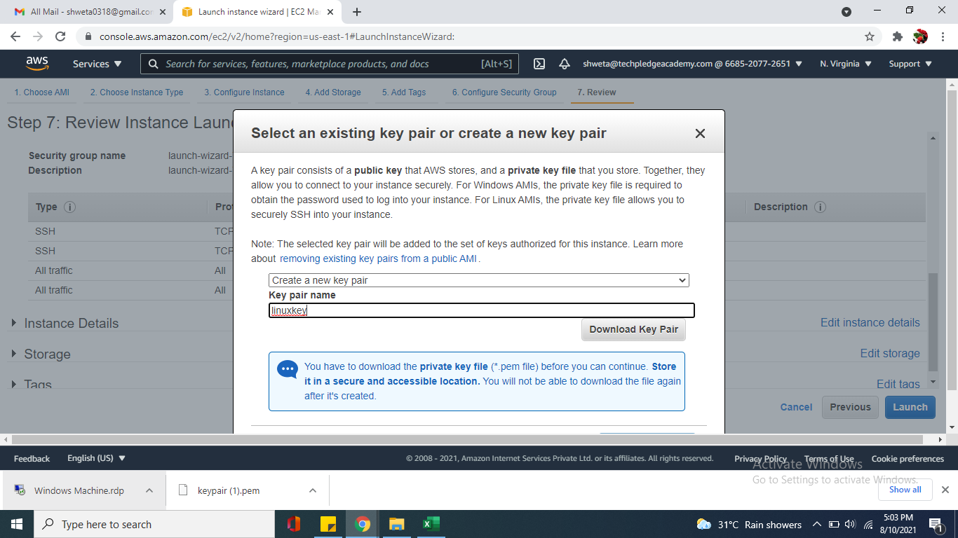

.

1. On the Instances screen, you can view the status of the launch. It takes a short time for an instance to launch. When you launch an instance, its initial state is pending. After the instance starts, its state changes to running and it receives a public DNS name.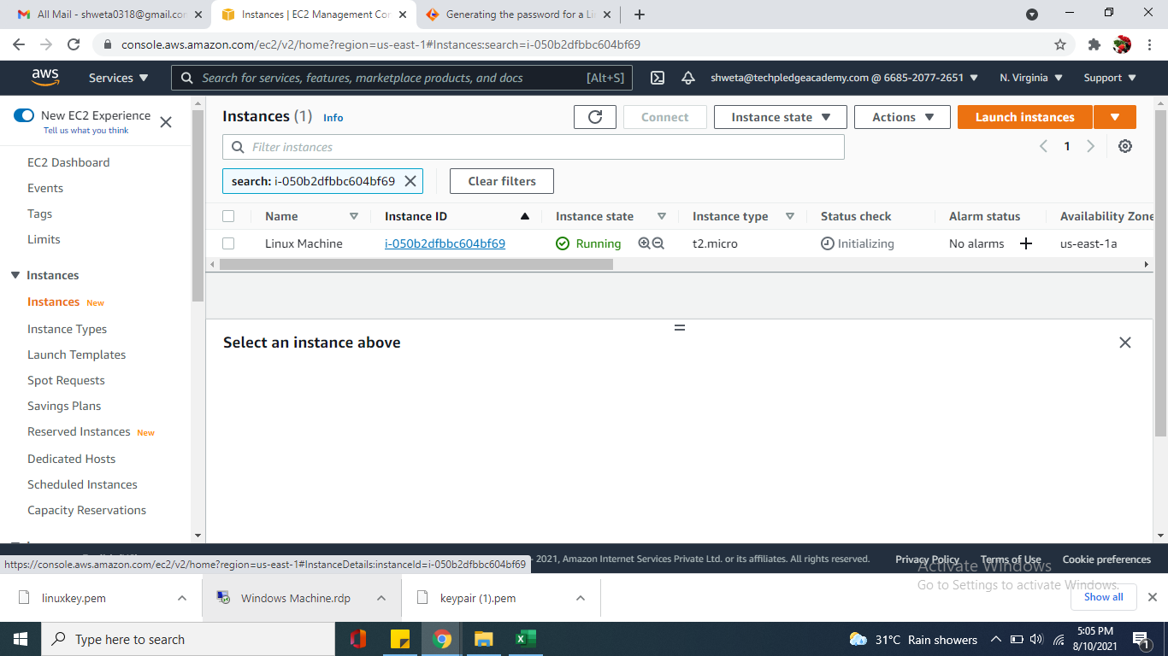
2. It can take a few minutes for the instance to be ready so that you can connect to it. Check that your instance has passed its status checks; you can view this information in the Status check column.

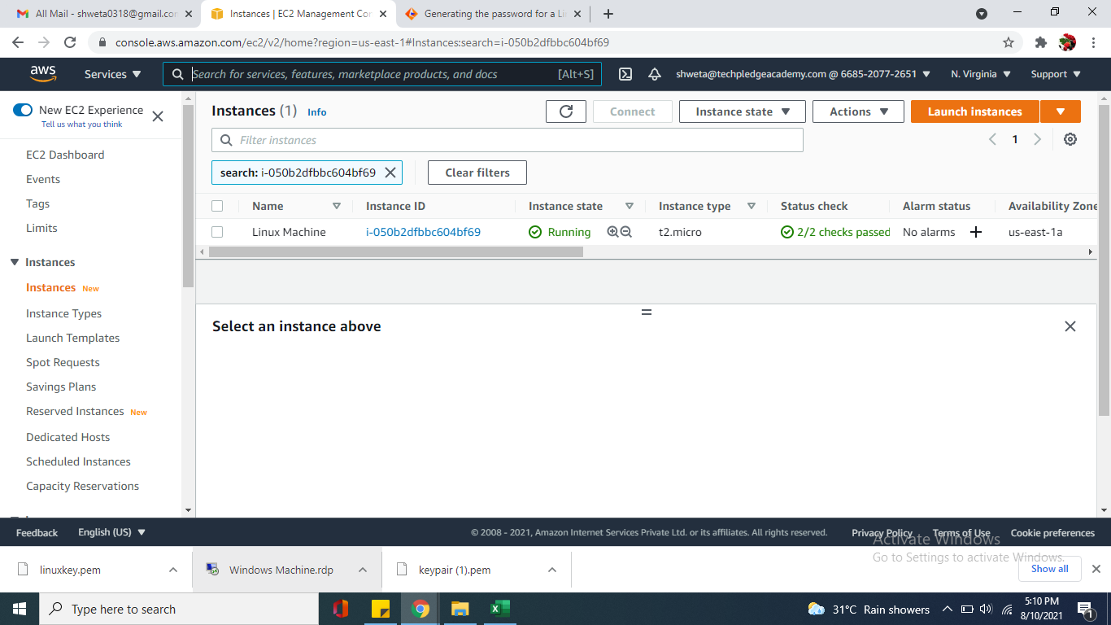

**SECTION 5 CONNECT TO LINUX INSTANCE**

**A] If your local computer operating system is Linux or macOS X**

**Connect Linux Instance using the Amazon EC2 console (browser-based client)**

You can connect to an instance using the Amazon EC2 console (browser-based client) by selecting the instance from the console and choosing to connect using EC2 Instance Connect. Instance Connect handles the permissions and provides a successful connection.

**To connect to your instance using the browser-based client from the Amazon EC2 console**

1. Open the Amazon EC2 console at *https://console.aws.amazon.com/ec2/*.
2. In the navigation pane, choose **Instances**.
3. Select the instance and choose **Connect**.
4. Choose **EC2 Instance Connect**.
5. Verify the user name and choose **Connect** to open a terminal window.

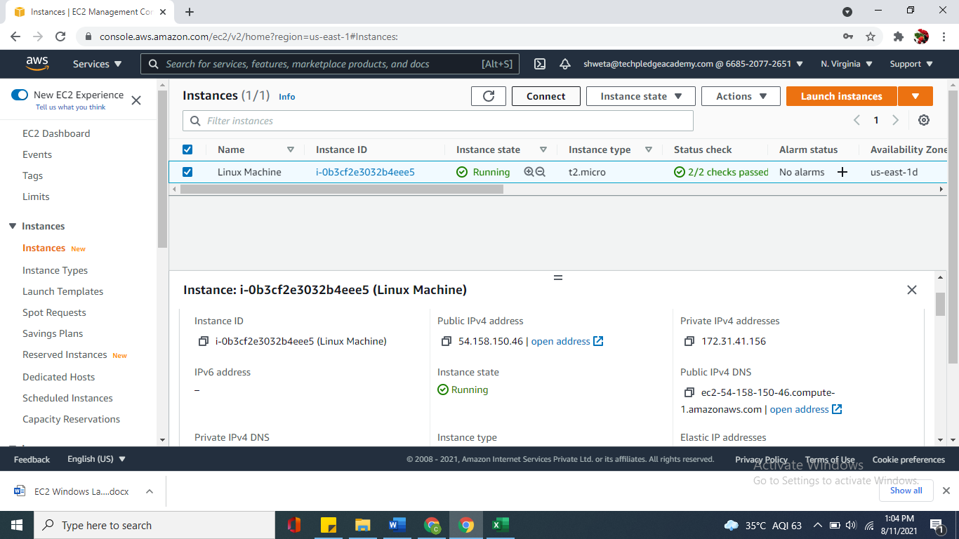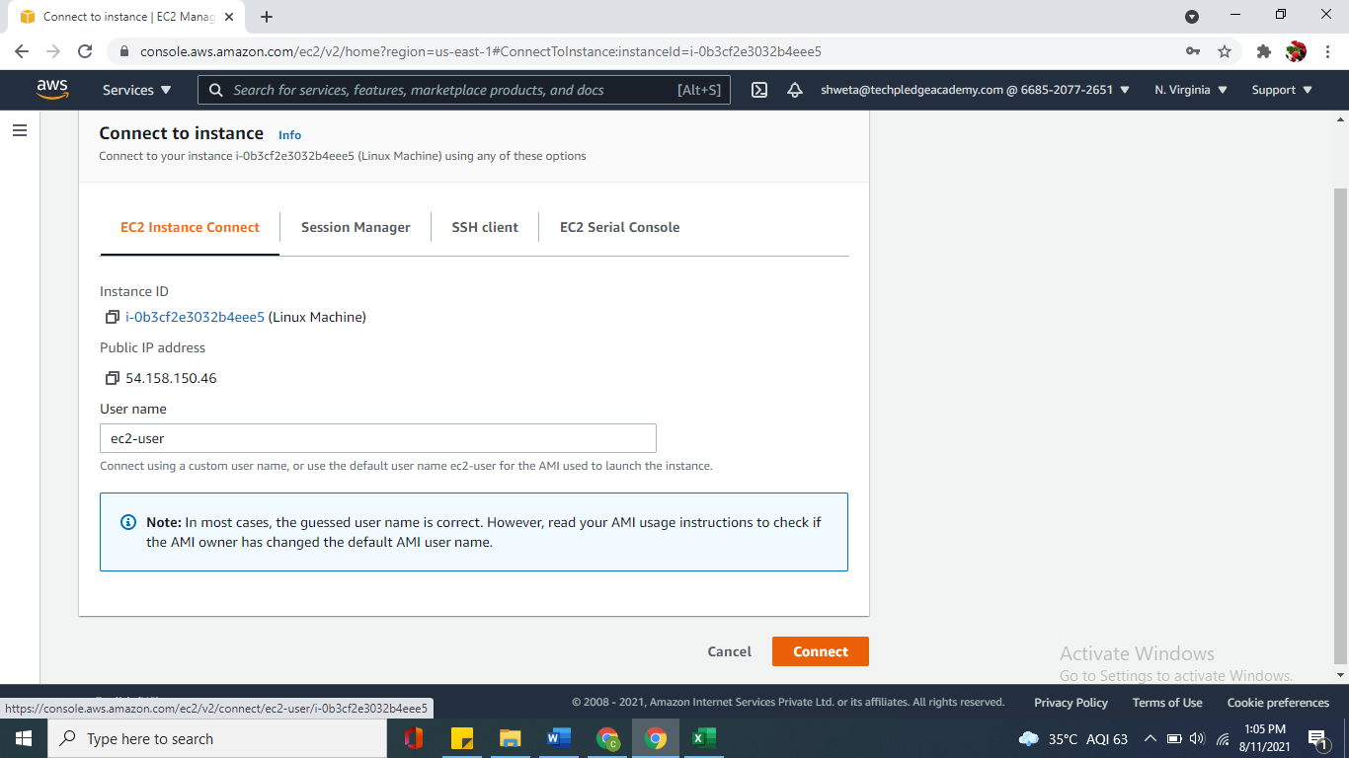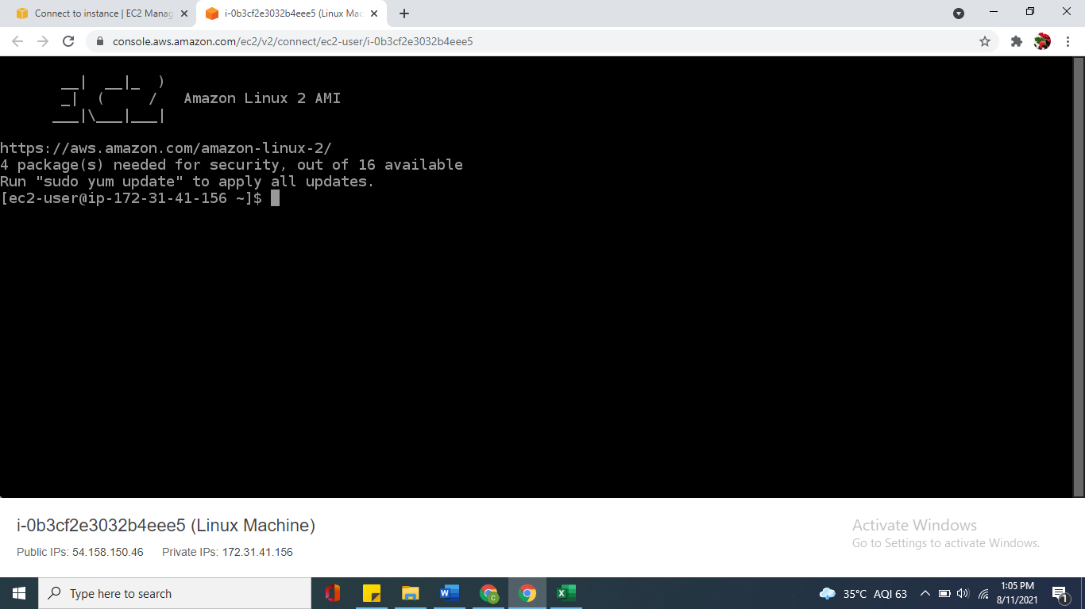

**B] If your local computer operating system is Windows**

**Connect to your Linux instance from Windows using PuTTY**

**Step 1:- Install PuTTY on your local computer**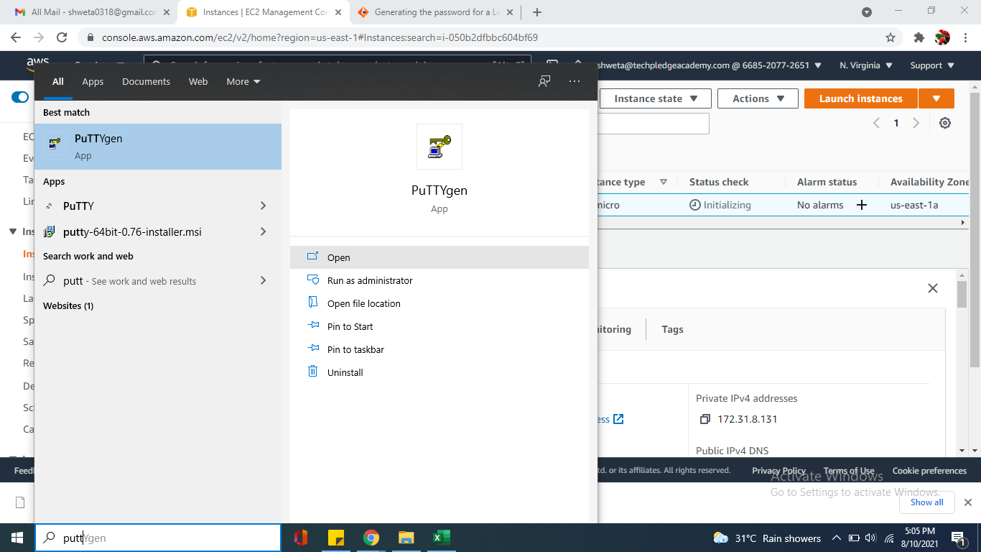

**Step 2:-Convert your private key using PuTTYgen**

1. From the Start menu, choose All Programs, PuTTY, PuTTYgen.
2. Under Type of key to generate, choose RSA.
3. Choose Load. By default, PuTTYgen displays only files with the extension .ppk. To locate your .pem file, choose the option to display files of all types.
4. Select your .pem file for the key pair that you specified when you launched your instance and choose Open. PuTTYgen displays a notice that the .pem file was successfully imported. Choose OK.
5. To save the key in the format that PuTTY can use, choose Save private key. PuTTYgen displays a warning about saving the key without a passphrase. Choose Yes. Give name to your file and private key file gets saved with .ppk extension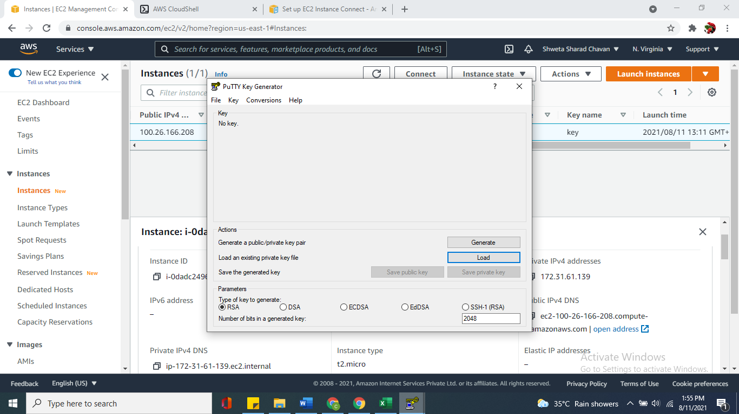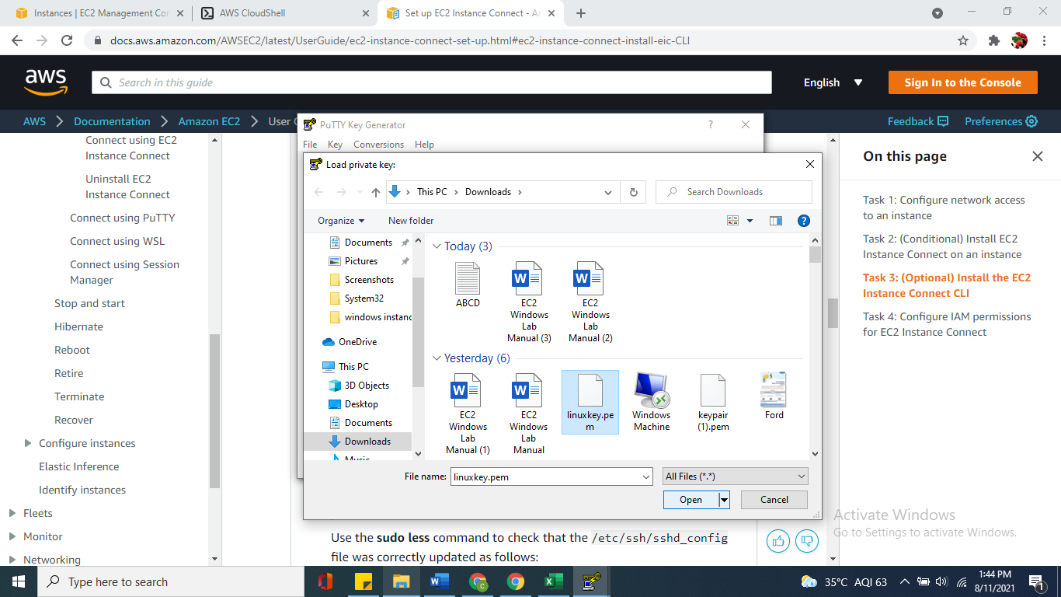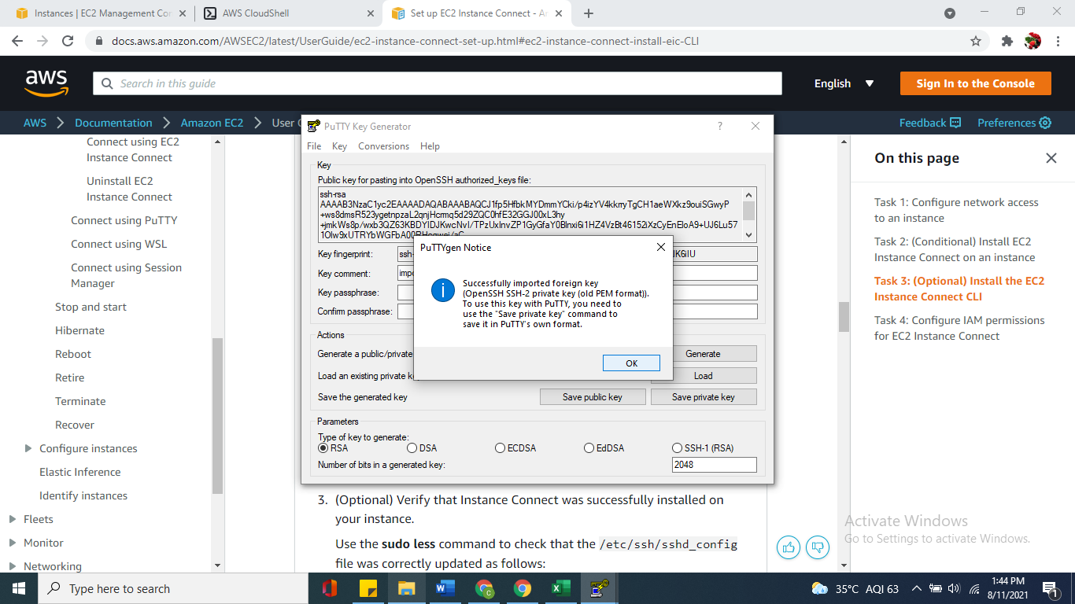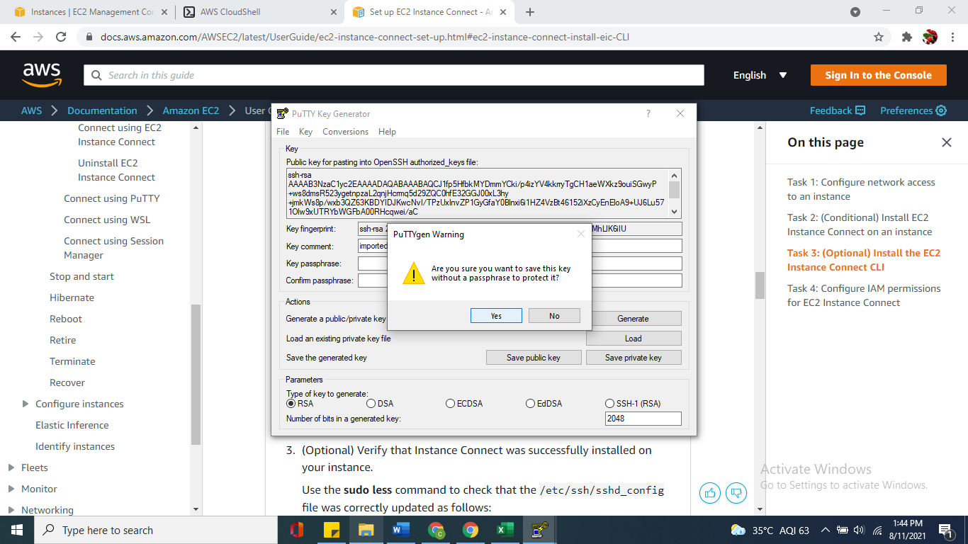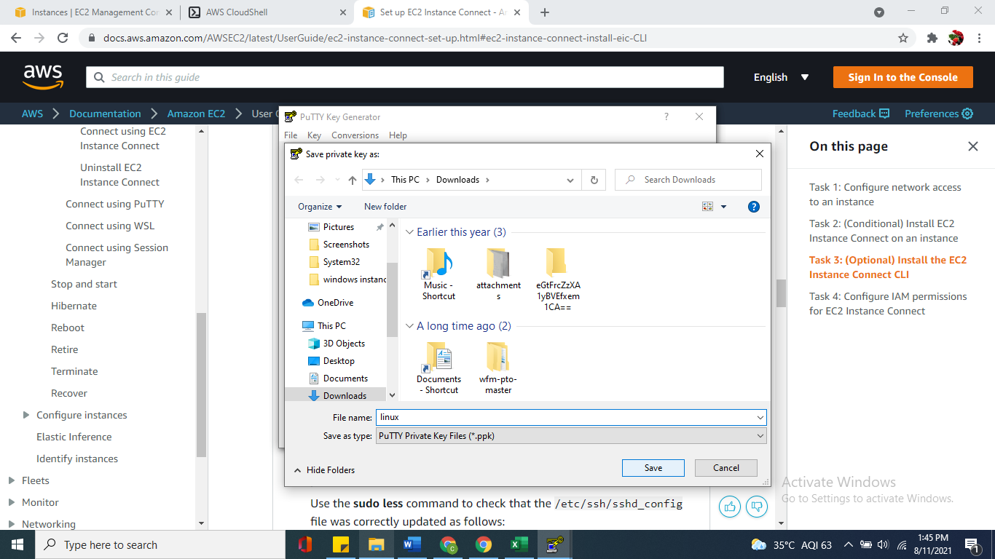

**Step 3:-To connect to your instance using PuTTY**

1. Start PuTTY
2. In the **Category** pane, choose **Session** and complete the following fields:
   1. In the **Host Name** box
      * (Public DNS) To connect using your instance's public DNS name, enter *my-instance-user-name*@*my-instance-public-dns-name*.
   2. Ensure that the **Port** value is 22.
   3. Under **Connection type**, select **SSH**.

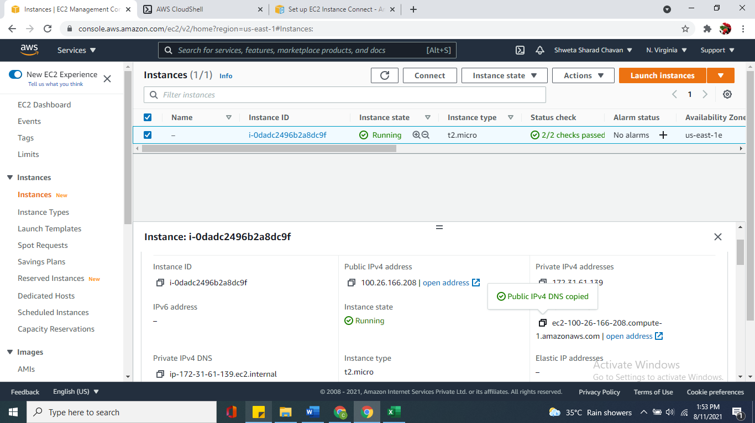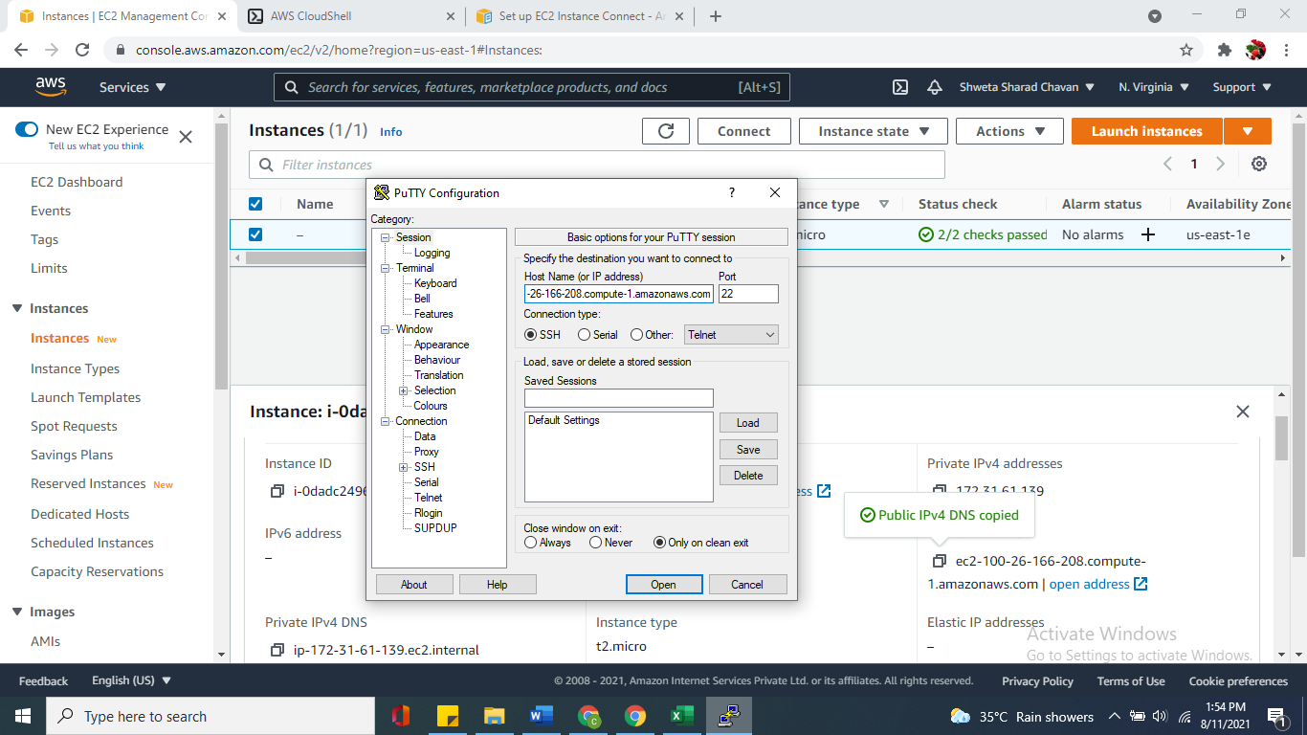

1. In the **Category** pane, expand **Connection**, expand **SSH**, and then choose **Auth**. Complete the following:
   1. Choose **Browse**.
   2. Select the .ppk file that you generated for your key pair and choose **Open**.
   3. (Optional) If you plan to start this session again later, you can save the session information for future use. Under **Category**, choose **Session**, enter a name for the session in **Saved Sessions**, and then choose **Save**.
   4. Choose **Open**.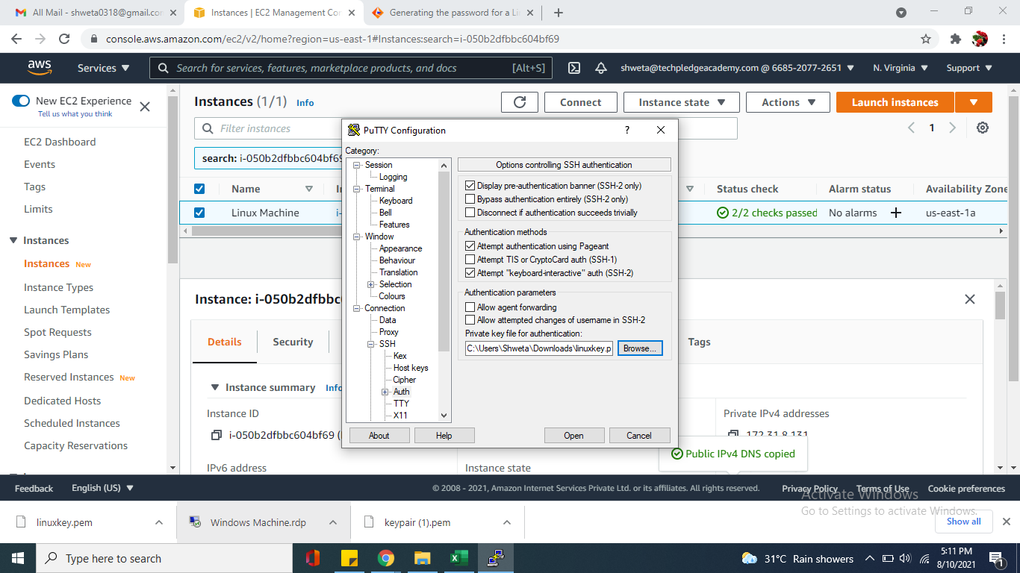
2. If this is the first time you have connected to this instance, PuTTY displays a security alert dialog box that asks whether you trust the host to which you are connecting. Choose **Yes**. A window opens and you are connected to your instance.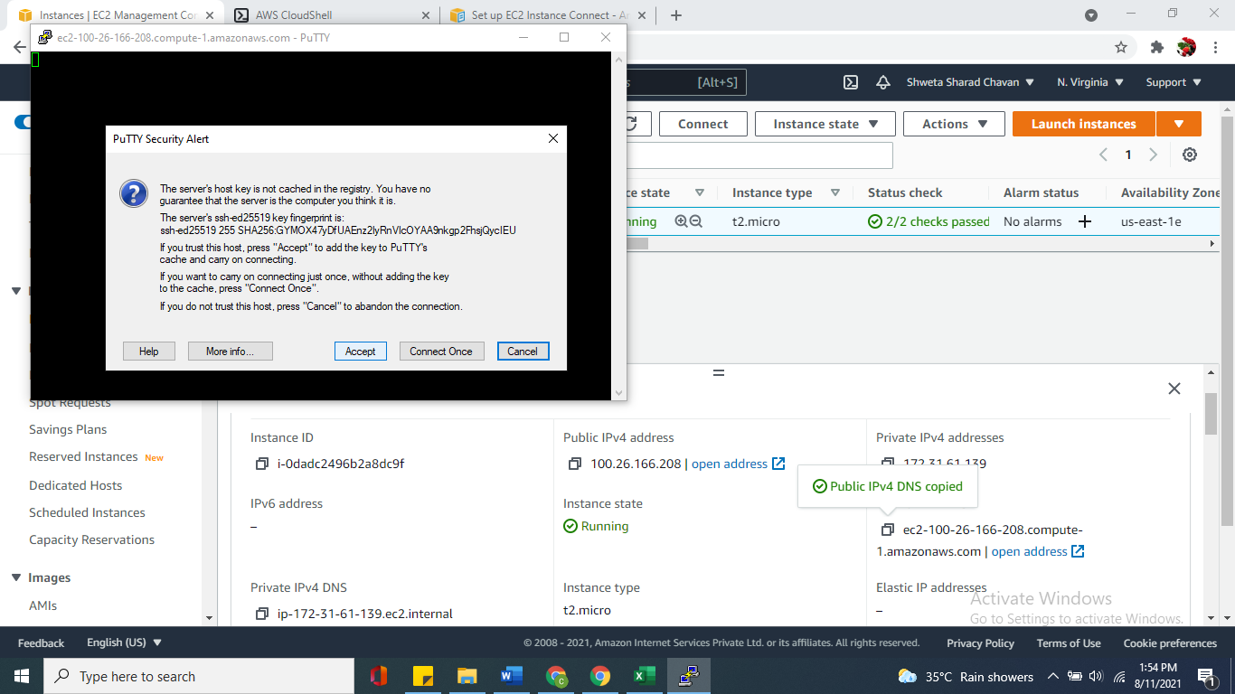

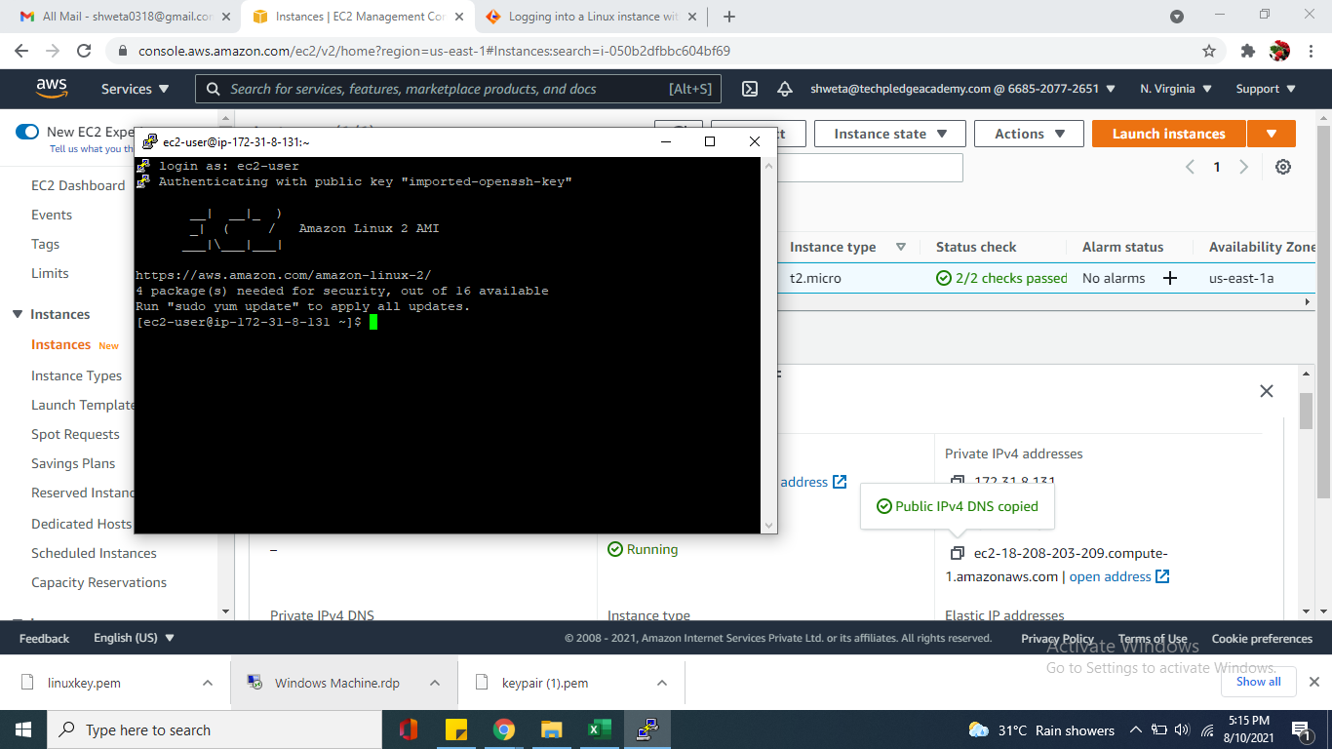

**SECTION 6 Clean Up Your Instance**

After you've finished with the instance that you created ,you should clean up by terminating the instance if no more required.

**Note:**

***Terminating an instance effectively deletes it; you can't reconnect to an instance after you've terminated it.***

If you launched an instance that is not within the AWS Free Tier, you'll stop incurring charges for that instance as soon as the instance status changes to shutting down or terminated. To keep your instance for later, but not incur charges, you can stop the instance now and then start it again later.

**To terminate your instance**

**Step 1**: In the navigation pane, choose **Instances**. In the list of instances, select the instance.

**Step 2:** Choose **Instance state**, **Terminate instance**.

**Step 3:** Choose **Terminate** when prompted for confirmation.

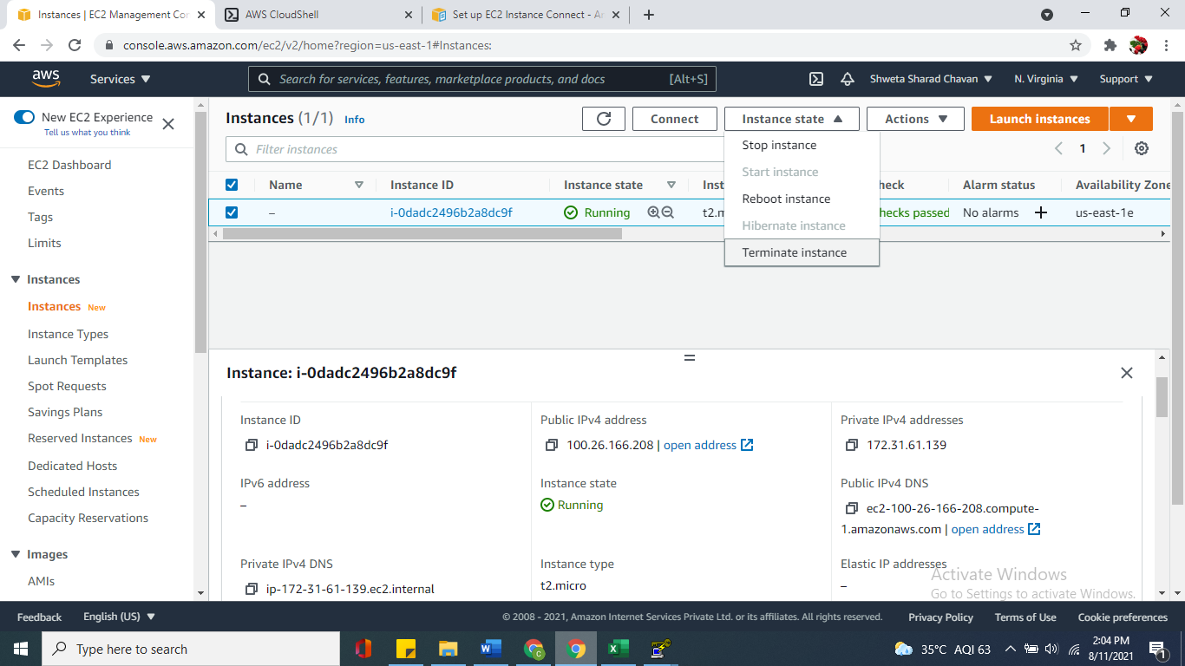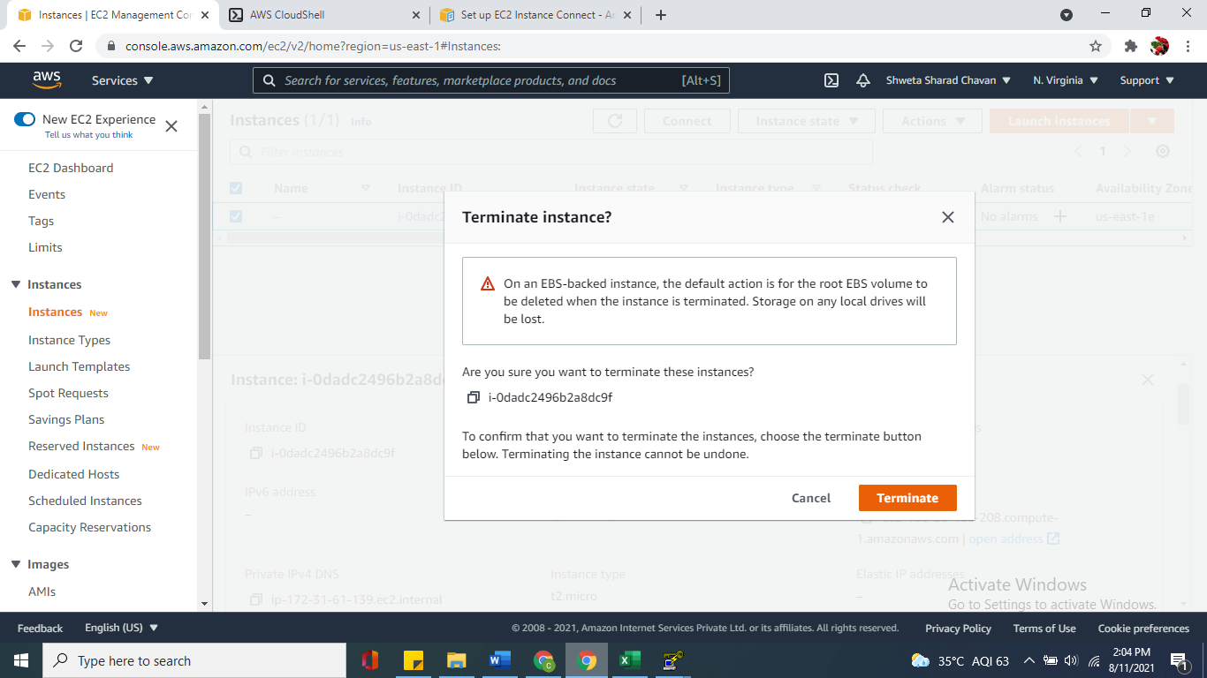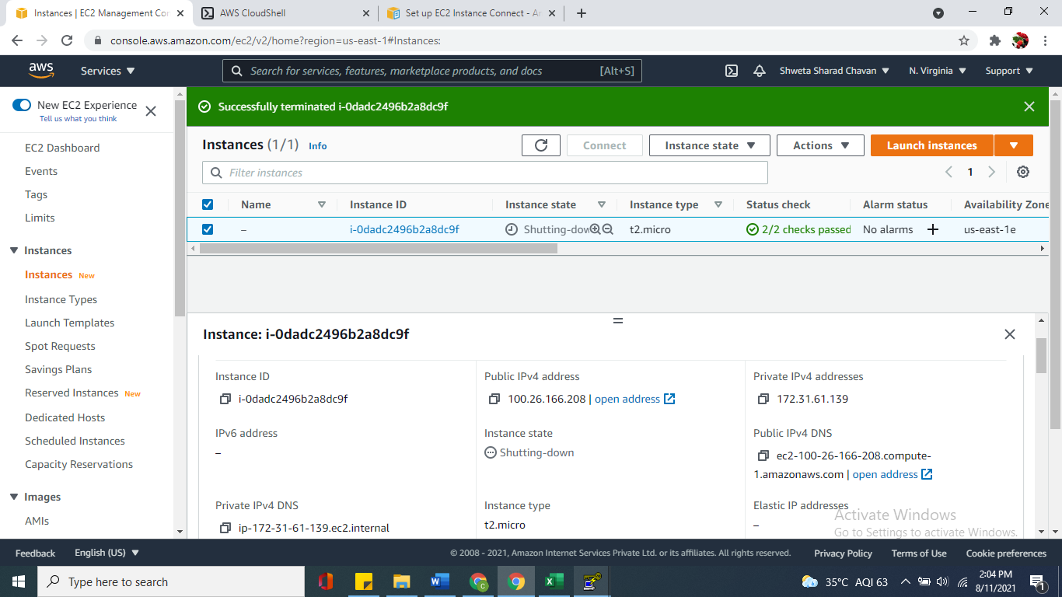

Amazon EC2 shuts down and terminates your instance. After your instance is terminated, it remains visible on the console for a short while, and then the entry is automatically deleted. You cannot remove the terminated instance from the console display yourself.